**Lab 6**

**Unconditional Loop**

**Object:**

**To understand the concept of loop in assembly language.**

**Theory**

**Loop**

A loop is a sequence of instructions that is repeated. The number of times to repeat may be known in advance, or it may depend on conditions i.e. it is a count-controlled loop.

A FOR loop is implemented using the LOOP instruction. The counter for the loop is the CX register, which is initialized to loop count, which is the number of times the loop is executed. Execution of the LOOP instruction causes CX to be decremented automatically. If CX becomes 0, the next instruction after loop is done.

**Lab Tasks**

1. **Write a program that prints a character 100 times using loop.**

**Code:**

.model small

.stack 100h

.code

main proc

mov ah,02h ;Display a character

mov cx,100 ;Number of times loop will execute

mov dl,'*' ;Character to be printed

print: ;loop starts from here

int 21h ;Loop body

Loop print ;executes the For loop

mov ah,4ch ;DOS exit

int 21h

main endp

end main

**Output:**



1. **To print all ASCII Characters.**

**Assembly Code:**

.model small

.stack 100h

.data

.code

main proc

; ACSII Characters ranges from 0-255

mov cx,256 ; 256 times display

mov ah,02h ; set output function

mov dl,0 ; initialize from 0

next:

int 21h ;print ASCII character

inc dl ;increment DL to next ASCII character

loop next

;return to DOS

mov ah,4ch ;exit program with return code

int 21h ;DOS exit

main endp

end main

**Output:**



1. **Write a program that prints a character 10 times using loop on next line.**

**Code:**

.model small

.stack 100h

nl macro

mov ah,02h

mov dl,0dh

int 21h

mov ah,02h

mov dl,0ah

int 21h

endm

.code

main proc

mov cx,10

print:

mov ah,02h

mov dl,'*'

int 21h

nl

loop print

mov ah,4ch

int 21h

main endp

end

**Output:**

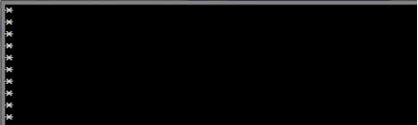

1. **Write a program that prints STRINGS in new line using loop.**

**Code:**

.model Small

.Stack 100h

.data

MSG1 db "Mavra Waseem $"

MSG2 db "Computer Science $"

MSG3 db "SMI University $"

.code

main proc

mov cx, 4h

Print:

mov ax, @data

mov ds, ax

mov ah, 09h

mov dx, offset MSG1

int 21h

mov ah, 4ch

mov ah, 02h

mov dl, 0dh

Int 21h

mov ah, 02h

mov dl, 0ah

Int 21h

mov ax, @data

mov ds, ax

mov ah, 09h

mov dx, offset MSG2

int 21h

mov ah, 4ch

mov ah, 02h

mov dl, 0dh

Int 21h

mov ah, 02h

mov dl, 0ah

Int 21h

mov ax, @data

mov ds, ax

mov ah, 09h

mov dx, offset MSG3

int 21h

mov ah, 4ch

mov ah, 02h

mov dl, 0dh

Int 21h

mov ah, 02h

mov dl, 0ah

Int 21h

Loop Print

mov ah, 4ch

Int 21h

main endP

end

**Lab Assignments:**

**Task # 1: Write a Program to Display ASCII characters from A to Z through   
 Looping.**

**Task # 2: Write a Program to Display ASCII characters from a to z through   
 Looping.**

**Task # 3: Write a Program to Display ASCII characters from Z to A through   
 Looping.**

**Task # 3: Write a Program to Display ASCII characters from 0 to 9 through   
 Looping.**

**Task # 4: Write a Program to Display ASCII characters from 9 to 0 through   
 Looping.**

**Task # 5: Write a Program to Display ASCII characters from z to a through   
 Looping.**

**Task # 7: Write a Program to Display ASCII characters from A-Z & z-a   
 through Looping.**

**Task # 8: Write a Program to Display ASCII characters from Z-A & a-z   
 through Looping.**

**Task # 9: Write a Program to print your name 10 times.**

**Task # 10: Write a program in Assembly Language to print following pattern:**

**0iiiiii0iiiiii0iiiiii0iiiiii0**

**Assignments**

**Task # 1: Write a Program to Display ASCII characters from A to Z through   
 Looping.**

**Experiment Code:**

.model small

.stack 100h

.code

main proc

    mov ah,02h

mov cx,26

    mov dl,65

    print:

    int 21h

    inc dl

    loop print

  mov ah,4ch

  int 21h

main endp

end

**Output:**

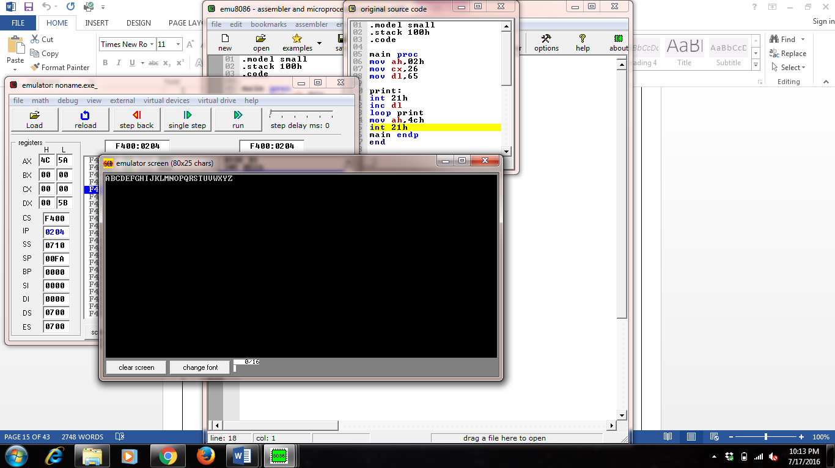

**Task # 2: Write a Program to Display ASCII characters from a to z through   
 Looping.**

**Experiment Code:**

.model small

.stack 100h

.code

main proc

    mov ah,02h

mov cx,26

    mov dl,97

    print:

    int 21h

    inc dl

    loop print

  mov ah,4ch

  int 21h

main endp

end

**Output:**

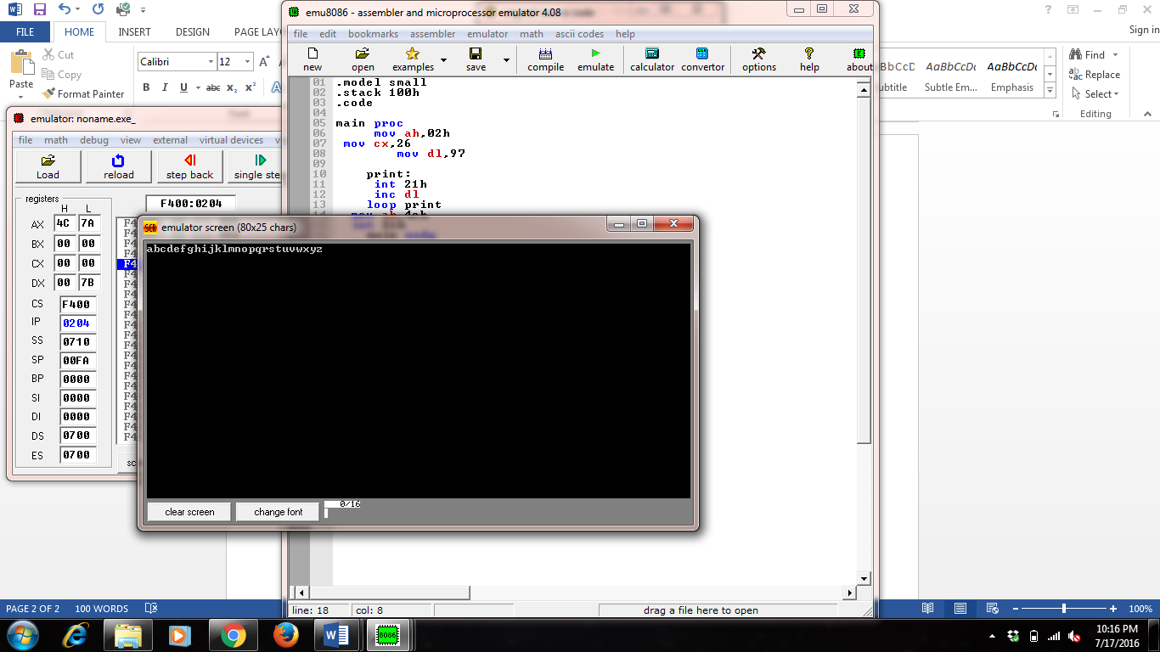

**Task # 3: Write a Program to Display ASCII characters from 0 to 9 through   
 Looping.**

**Experiment Code:**

.model small

.stack 100h

.code

main proc

    mov ah,02h

mov cx,10

    mov dl,48

    print:

    int 21h

    inc dl

    loop print

  mov ah,4ch

  int 21h

main endp

end

**Output:**

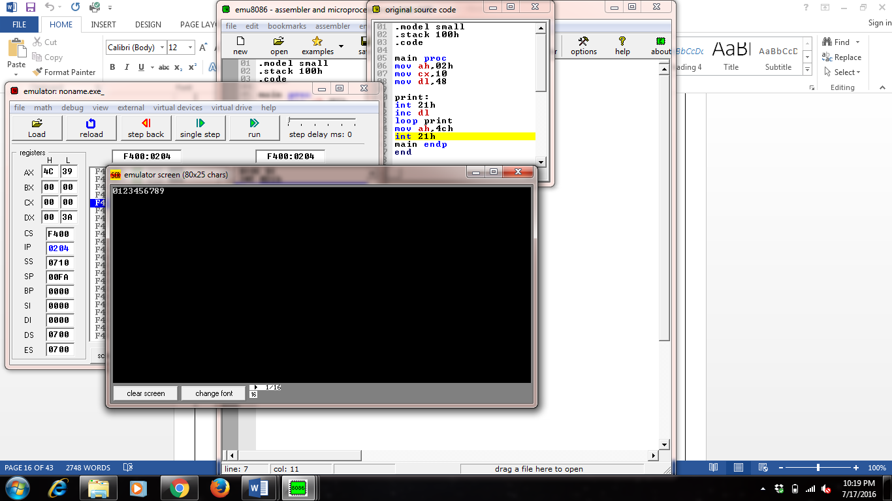

**Task # 4: Write a Program to Display ASCII characters from Z to A   
 through Looping.**

**Experiment Code:**

.model small

.stack 100h

.code

main proc

    mov ah,02h

mov cx,26

    mov dl,90

    print:

    int 21h

    dec dl

    loop print

  mov ah,4ch

  int 21h

main endp

end

**Output:**

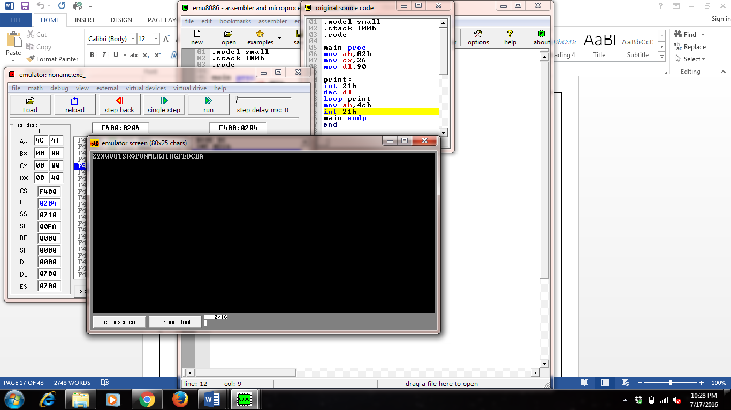

**Task # 5: Write a Program to Display ASCII characters from z to a through   
 Looping.**

**Experiment Code:**

.model small

.stack 100h

.code

main proc

    mov ah,02h

mov cx,26

    mov dl,122

    print:

    int 21h

    dec dl

    loop print

  mov ah,4ch

  int 21h

main endp

end

**Output:**

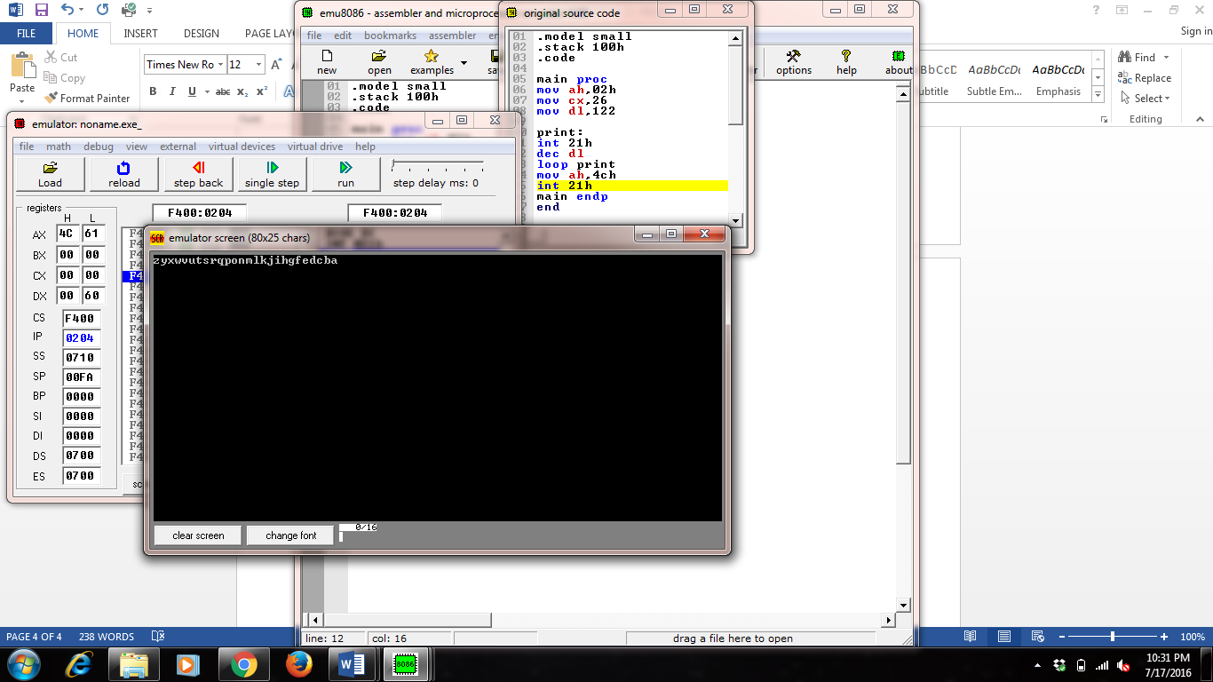

**Task # 6: Write a Program to Display ASCII characters from 9 to 0 through   
 Looping.**

**Experiment Code:**

.model small

.stack 100h

.code

main proc

    mov ah,02h

mov cx,10

    mov dl,57

    print:

    int 21h

    dec dl

    loop print

  mov ah,4ch

  int 21h

main e48ndp

end

**Output:**



**Task # 7: Write a Program to Display ASCII characters from A-Z & z-a   
 through Looping.**

**Experiment Code:**

.model small

.stack 100h

.code

main proc

mov ah,02h

mov cx,26

mov dl,65

print:

Int 21h

inc dl

loop print

mov ah,02

mov cx,26

mov dl,122

print1:

Int 21h

dec dl

loop print1

mov ah,4ch

int 21h

main endP

end

**Output:**



**Task # 8: Write a Program to Display ASCII characters from Z-A & a-z   
 through Looping.**

**Experiment Code:**

.model small

.stack 100h

.code

main proc

mov ah,02h

mov cx,26

mov dl,90

print:

Int 21h

dec dl

loop print

mov ah,02

mov cx,26

mov dl,97

print1:

Int 21h

inc dl

loop print1

mov ah,4ch

int 21h

main endP

end

**Output:**



**Program to print name 10 times**

 .MODEL SMALL  
.STACK 100H  
.DATA  
 **M1  DB  'Maria',0DH,0AH,'$' ; This line instructs that need to print Maria**  
.CODE  
MAIN PROC  
MOV AX,@DATA  
MOV DS,AX  
  
**MOV CX,10 ; The name 'Maria ' will print for 10 times**  
PRINT_LOOP:  
  
MOV AH,9  
LEA DX,M1  
INT 21H  
DEC CX  
  
JNZ PRINT_LOOP  
  
MOV AH,4CH  
INT 21H  
  
MAIN ENDP  
END MAIN

**Write a program in Assembly Language to print following pattern:**

**0iiiiii0iiiiii0iiiiii0iiiiii0**

**Assembly Code**

.code

main proc

;4 times display "0iiiiii"

mov cx,4

outer:

mov ah,02h

mov dl,"0"

int 21h

mov bx,cx

mov cx,6

inner:

mov ah,02h

mov dl,"i"

int 21h

loop inner

mov cx,bx

loop outer

mov ah,02h

mov dl,"0"

int 21h

;return to DOS

mov ah,4ch ;exit program with return code

int 21h ;DOS exit

main endp

end main

**Lab Assignments:**

**Task # 1: Write a Program to Display ASCII characters from A to Z through   
 Looping.**

**Source Code:**

.model small

.stack 100h

.data

.code

start:

mov cx,25

mov ah,02

mov dl,41h

int 21h

l1:

inc dl

int 21h

loop l1

mov ah,4ch

int 21h

end start

**Output:**

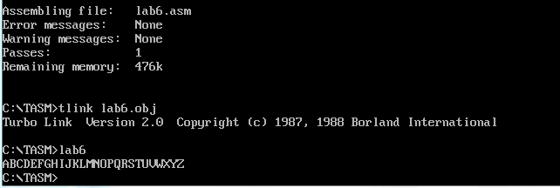

**Task # 2: Write a Program to Display ASCII characters from a to z through   
 Looping.**

**Source Code:**

.model small

.stack 100h

.data

.code

start:

mov cx,25

mov ah,02

mov dl,61h

int 21h

l1:

inc dl

int 21h

loop l1

mov ah,4ch

int 21h

end start

**Output:**

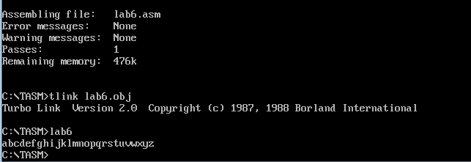

**Task # 3: Write a Program to Display ASCII characters from Z to A through   
 Looping.**

**Source Code:**

.model small

.stack 100h

.data

.code

start:

mov cx,25

mov ah,02

mov dl,90

int 21h

l1:

dec dl

int 21h

loop l1

mov ah,4ch

int 21h

end start

**Output:**

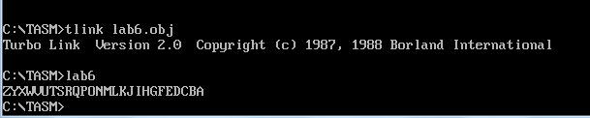

**Task # 4: Write a Program to Display ASCII characters from 0 to 9 through   
 Looping.**

**Source Code:**

.model small

.stack 100h

.data

.code

start:

mov cx,9

mov ah,02

mov dl,48

int 21h

l1:

inc dl

int 21h

loop l1

mov ah,4ch

int 21h

end start

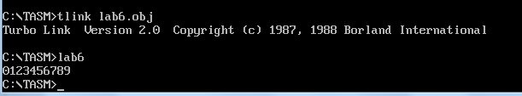**Output:**

**Task # 4: Write a Program to Display ASCII characters from 9 to 0 through   
 Looping.**

**Source Code:**

.model small

.stack 100h

.data

.code

start:

mov cx,9

mov ah,02

mov dl,39h

int 21h

l1:

dec dl

int 21h

loop l1

mov ah,4ch

int 21h

end start

**Output:**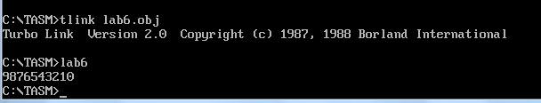

**Task # 5: Write a Program to Display ASCII characters from z to a through   
 Looping.**

**Source Code:**

.model small

.stack 100h

.data

.code

start:

mov cx,25

mov ah,02

mov dl,7Ah

int 21h

l1:

dec dl

int 21h

loop l1

mov ah,4ch

int 21h

end start

**Output:**

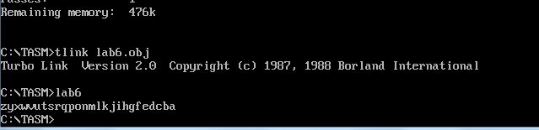

**Task # 7: Write a Program to Display ASCII characters from A-Z & z-a   
 through Looping.**

**Source Code:**

.model small

.stack 100h

.data

.code

start:

mov ah,02

mov cx,25

mov dl,41h

int 21h

l1:

inc dl

int 21h

loop l1

mov dl,0ah

mov ah,02h

int 21h

mov dl,0dh

mov ah,02h

int 21h

mov ah,02

mov cx,25

mov dl,7Ah

l2:

int 21h

dec dl

loop l2

mov ah,4ch

int 21h

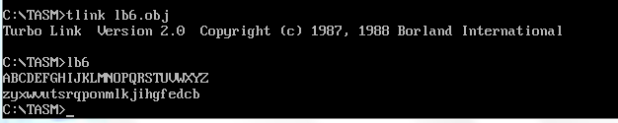end start

**Output**

**Task # 8: Write a Program to Display ASCII characters from Z-A & a-z   
 through Looping.**

**Source Code:**

.model small

.stack 100h

.data

.code

start:

mov ah,02

mov cx,25

mov dl,90

int 21h

l1:

dec dl

int 21h

loop l1

mov dl,0ah

mov ah,02h

int 21h

mov dl,0dh

mov ah,02h

int 21h

mov ah,02

mov cx,25

mov dl,61h

l2:

int 21h

inc dl

loop l2

mov ah,4ch

int 21h

end start

**Output:**

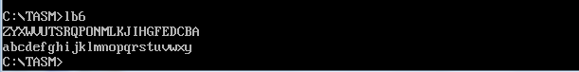

**Task # 9: Write a Program to print your name 10 times.**

**Source Code:**

.model small

.stack 100h

.data

var db "ABDUL RAFEH",0dh,0ah,'$'

.code

start:

mov ax,@data

mov ds,ax

mov cx,10

mov ah,09

lea dx,var

l1:

int 21h

loop l1

mov ah,4ch

int 21h

end start

**Output:**

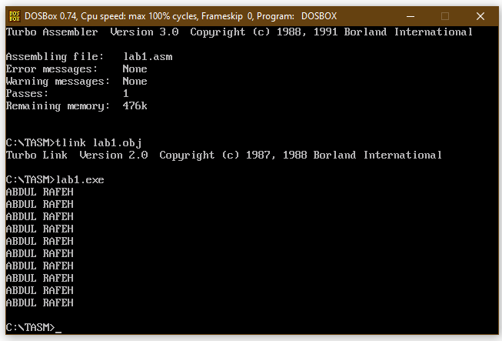

**Task # 10: Write a program in Assembly Language to print following pattern:**

**0iiiiii0iiiiii0iiiiii0iiiiii0**

**Source Code:**

.model small

.stack 100h

.data

var db "0iiiii",'$'

.code

start:

mov ax,@data

mov ds,ax

mov cx,4

mov ah,09

lea dx,var

l1:

int 21h

loop l1

mov ah,4ch

int 21h

end start

**Output:**

